## Description of Unusual Cases

**_pureTX_:** data was recorded by the microphone of the RPi which transmit the signals.

**_pureRX_:** data was recorded by the microphone of the RPi which does not transmit the signals.

For the data with **_pureRX_:**

**RawData_pureRX_270cm_facingUp**: two devices with distance 270 cm. Both devices (speaker and mic) face up.

**RawData_pureRX_310cm_NLOS10R**: two devices with distance 310 cm. There is one block with 10 cm from the receiver RPi.

**RawData_pureRX_310cm_NLOS10T**: two devices with distance 310 cm. There is one block with 10 cm from the transmitter RPi.

**RawData_pureRX_310cm_NLOS50T**: two devices with distance 310 cm. There is one block with 50 cm from the transmitter RPi.

**RawData_pureRX_330cm_facingBackR**: two devices with distance 330 cm. The receiver RPi faces back to the transmitter RPi.

**RawData_pureRX_330cm_NLOS10R_facingBackT**: two devices with distance 330 cm. There is one block with 10 cm from the receiver RPi. The transmitter RPi faces back to the receiver RPi.

**RawData_pureRX_330cm_NLOS10T_facingBackR**: two devices with distance 330 cm. There is one block with 10 cm from the transmitter RPi. The receiver RPi faces back to the transmitter RPi.

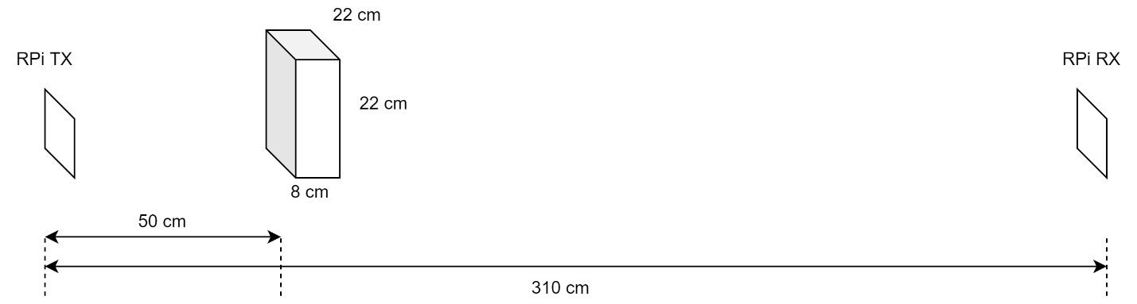

Figure : RawData_pureRX_310cm_NLOS50T

